|  |
| --- |
|  |
| LOAN PROCESS SYSTEM |
| PROJECT ANALYSIS |
| |  |  | | --- | --- | | **Faculty:** |  | | **Batch No:** |  | | **Group No:** | **5** | | **Student:** | |  |  |  | | --- | --- | --- | | **#** | **Student Name** | **RollNumber** | | **1.** | **Ta Van Tuyen** | **Student537143** | | **2.** | **Nguyen Thi Thu** | **Student521354** | | **3.** | **Nguyen Duy Tuan** | **Student534551** | | **4.** | **Nguyen Hoang Minh** | **Student534286** | | |
|  |
| **7/13/2010** |

|  |
| --- |
|  |



**Table of Content**

Contents

1. Problem Definition 2

2. Existing Scenario 2

3. Customer Requirement specification 2

4. Project Plan 3

5. System Requirement Specification 3

5.1. Hardware 3

5.2. Software 3

6. Data Flow Diagram ..……………………………………………………………………………………………………………………….4

7. Database Design………………………………………………………………………………………………………………………………7

7.1. Entity Relationship Diagram(ERD)……..……………………………………………………………..........................7

7.2. Table Design / Structure…………………………………………………………………………………………………8

8. Task sheet………………………………………………………………………………………………………………………..12

## Problem Definition

“QuickLoan” is a company involved in providing loans to its customers. They have branches set up at different parts of the city. It caters to different types of loans like vehicle loan, house loan, personal loan and loan to student higher studies.

Now, company has decided to computerize entire this processing system.

## Existing Scenario

Currently there are separate department for handling the different types of loans like for handling vehicle loans – Vehicle Finance Department, Housing Loans – Home Finance, personal loans – Personal Finance and for educational loan – Educational Finance.

When any person applies for the loan he has to fill the application form mentioning the personal and details of loan requirement. Depending on the type of loan, the application is forwarded to the concerned department.

Further the details are verified by the respective department and the loan is sanctioned for the person. Also the department keeps track of the installments paid by the customer.

## Customer Requirement specification

Create Loan Processing System by Java Application that can:

* Accept the customer details as address, organization, gross salary etc.. The user should be able to choose the type of loan, loan amount, period and the branch from which the loan is asked.
* There is the unique account number for each registered people so that users can trace and manage these people’s details at any time by just entering this number. User should be allowed to edit only the profile and view loan amount, and date of disbursal of loan, monthly installment, number of installments paid till date, balance to be paid and durations of the loan.
* Track of the installments paid by the customer.
* Perform search based on the loan account number, amount of loan and duration of loan.
* Can generate these various reports.
  + The customer’s report will provide the personal details of customer such as name, contact details, loan amount, and date of disbursal of loan, monthly installment, number of installments paid till date, balance to be paid and duration of the loan.
  + The payment due report will provide the details of customers for whom the date of payment has already passed but the payment is not yet done.
  + Fine report will provide the details of the fine collected for the month with details of customer.
* The help option makes the user aware the various functions of the system.

## Project Plan

|  |  |  |  |
| --- | --- | --- | --- |
| STT | Task | Start Date | End Date |
| 1 | Create document and design database | July 3, 2012 | July 12, 2012 |
| 2 | Design interface and fuction module | July 12, 2012 | July 27, 2012 |
| 3 | Finish document, test application, create User Guide and Developer’s Guide. | July 27, 2012 | August 2,2012 |

## System Requirement Specification

### Hardware

* + - A minimum computer system that will help you access all the tools in the courses is a Pentium 4, Core Duo or better
    - 1G of RAM or better
    - HDD 5G free space available

### Software

* + - OS: Windows XP Services Pack 2
    - Java Virtual Machine
    - Java SE 6 or better
    - Net beans 6.1 or better
    - DBMS: SQL Server 2005 or better

## Data Flow Diagram

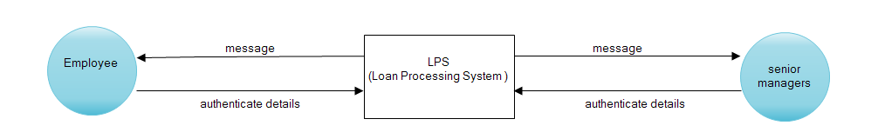

1. Context Diagram

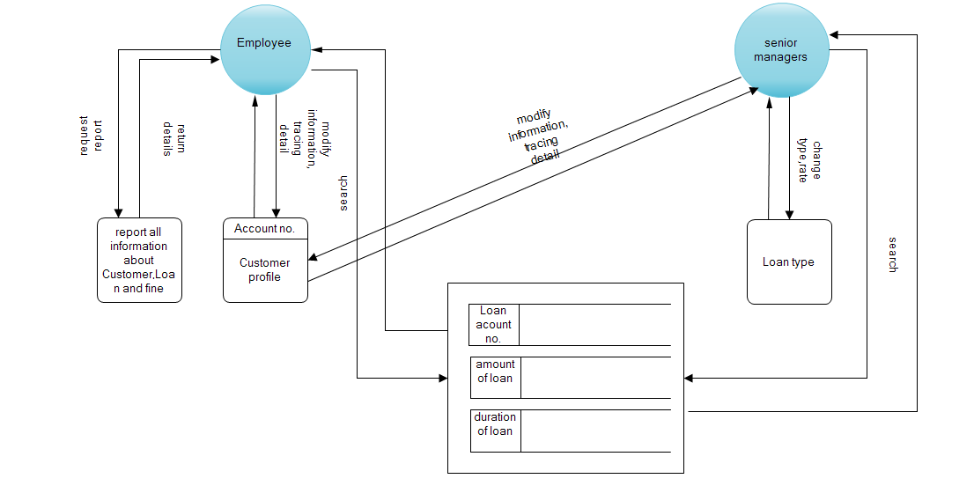

1. Level 0 – Application proccess

AcccountNo

Customer

Password

1. Login

Information Infomation

Member

Customer

1. Register

Old, New Pass

Member

Customer

Old, New Pass

1. Change Password

Notice Command  
 Database

Member

Resource Human

1. Member Proccess

Send information Re Retriev info

Result

Database Find

1. Statistics Total Loans

Send info Retriev info

Result

Database

1. Find Customer

Calculate Fine

*Send Retriev*

Customer

Fine list

1. Calculate Fine from Customer

## 7.Database Design

### . Entity Relationship Diagram(ERD)

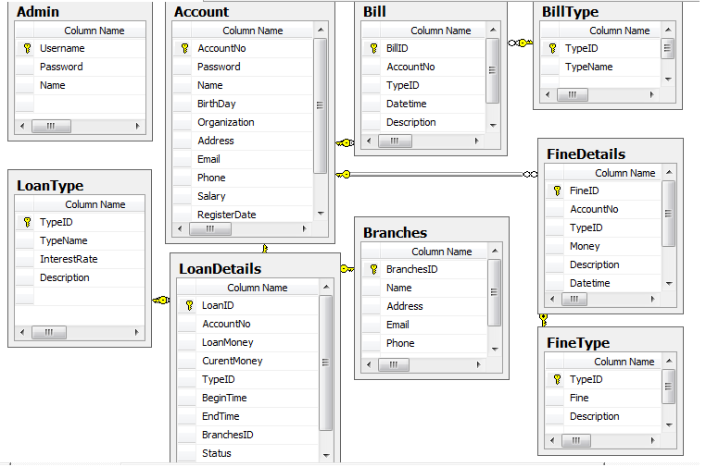

### Table Design/Structure

|  |  |  |  |  |  |  |
| --- | --- | --- | --- | --- | --- | --- |
| **Table: Admin** | | | | | | |
| **Field** | **Data type** | **Null** | **Default Value** | **Table-ref field** | **Key** | **Description** |
| UserName | varchar(50) | No | Identity |  | PK | Use to login program |
| Password | varchar(20) | No |  |  |  | Length>6 and <20 |
| Name | varchar(50) | No |  |  |  | Name of Admin |

|  |  |  |  |  |  |  |
| --- | --- | --- | --- | --- | --- | --- |
| **Table: Account** | | | | | | |
| **Field** | **Data type** | **Null** | **Default Value** | Table-ref field | Key | Description |
| AccountNo | Nchar(20) | No | Identity |  | PK | Register Account |
| Password | varchar(20) | No |  |  |  | Length>6 and <20 |
| Name | varchar(50) | No |  |  |  | Customer name of Account |
| BirthDay | Date | No |  |  |  | Day Of Birth(old year>18) |
| Organization | varchar(100) | No |  |  |  | Organization |
| Address | varchar(100) | No |  |  |  | Address of Customer |
| Email | varchar(50) | No |  |  |  | Email of Customer |
| Phone | nchar(12) | No |  |  |  | Phone length>9 and <13 |
| Salary | int | No |  |  |  | Salary >0 |
| RegisterDate | datetime | No |  |  |  | Register date |

|  |  |  |  |  |  |  |
| --- | --- | --- | --- | --- | --- | --- |
| **Table: Branches** | | | | | | |
| **Field** | **Data type** | **Null** | **Default Value** | **Table-ref field** | **Key** | **Description** |
| BranchesID | int | No | Identity,increment |  | PK | ID of Branches |
| Name | varchar(50) | No |  |  |  | Name of Banches |
| Address | varchar(100) | No |  |  |  | Address |
| Email | varchar(50) | No |  |  |  | Email |
| Phone | char(12) |  |  |  |  | Length>69 and <13 |

|  |  |  |  |  |  |  |
| --- | --- | --- | --- | --- | --- | --- |
| **Table: Bill** | | | | | | |
| **Field** | **Data type** | **Null** | **Default Value** | **Table-ref field** | **Key** | **Description** |
| BilID | Int | No | Identity,increment |  | PK | ID |
| AccountNo | Nchar(20) | No |  | Account.AccountNo |  | Code Account |
| Datetime | Datetime | No |  |  |  | Update time |
| TypeID | Int | No |  | TypeBill.TypeID |  | Type ID |
| Description | varchar(100) | No |  |  |  | Infomation |

|  |  |  |  |  |  |  |
| --- | --- | --- | --- | --- | --- | --- |
| **Table: TypeBill** | | | | | | |
| **Field** | **Data type** | **Null** | **Default Value** | **Table-ref field** | **Key** | **Description** |
| TypeID | Int | No | Identity, increment |  | PK | Type ID |
| TypeName | varchar(50) | No |  |  |  | Type name |

|  |  |  |  |  |  |  |
| --- | --- | --- | --- | --- | --- | --- |
| **Table: LoanType** | | | | | | |
| **Field** | **Data type** | **Null** | **Default Value** | **Table-ref field** | **Key** | **Description** |
| TypeID | Int | No | Identity,increment |  | PK | Type code |
| TypeName | varchar(50) | No |  |  |  | Type name |
| InterestRate | Int | No |  |  |  | % |
| Description | varchar(100) | No |  |  |  | Description |

|  |  |  |  |  |  |  |
| --- | --- | --- | --- | --- | --- | --- |
| **Table: LoanDetails** | | | | | | |
| **Field** | **Data type** | **Null** | **Default Value** | Table-ref field | Key | Description |
| LoanID | Int | No | Identity, increment |  | PK | ID |
| AccountNo | Nchar(20) | No |  | Account.AccountNo |  | Account Code |
| LoanMoney | Float | No |  |  |  | The first money |
| CurentMoney | Float | No |  |  |  | Curent money |
| TypeID | int | No |  | LoanType.TypeID |  | Loan type ID |
| BeginTime | Datetime | No |  |  |  | Begin |
| Endtime | Datetime | No |  |  |  | End |
| BranchesID | int | No |  | Branches.BranchesID |  | Branches ID |
| Status | Bit | No | 0 |  |  | Status of Loan |

|  |  |  |  |  |  |  |
| --- | --- | --- | --- | --- | --- | --- |
| **Table: FineType** | | | | | | |
| **Field** | **Data type** | **Null** | **Default Value** | Table-ref field | Key | Description |
| TypeID | Int | No | Identity, increment |  | PK | Fine type ID |
| Fine | Int | No |  |  |  | Fine name |
| Description | Nvarchar(100) | No |  |  |  | Description |

|  |  |  |  |  |  |  |
| --- | --- | --- | --- | --- | --- | --- |
| **Table: FineDetails** | | | | | | |
| **Field** | **Data type** | **Null** | **Default Value** | Table-ref field | Key | Description |
| FineID | Int | No | Identity, increment |  | PK | ID |
| TypeID | Int | No |  | FineType.TypeID |  | Fine type ID |
| AccountNo | Nchar(20) | No |  | Account.AccountNo |  | Account ID |
| Money | float | No |  |  |  | Money fines |
| Description | varchar(100) | No |  |  |  | Description |
| Datetime | Datetime | No |  |  |  | Update date |

## 8.Task Sheet.

**TASK SHEET WRITE DOCUMENT**

|  |  |  |  |  |  |  |
| --- | --- | --- | --- | --- | --- | --- |
| **Project**  **Ref No: 4** | | **Project Title:**  **Loan Processing System** | **Date of Preparation of Activity Plan** | | | |
| **Sr. No.** | **Task** | | **Actual Start Date** | **Actual Days** | **Team Member Names** | **Status** |
| 01 | Introduction | | 03-7-2012 | 7 | NGUYEN THI THU | Completed |
| 02 | Existing Scenario | | NGUYEN THI THU | Completed |
| 03 | Customer Requirement specification | | NGUYEN THI THU | Completed |
| 04 | System Requirement Specification | | NGUYEN THI THU | Completed |
| 05 | Data Flow Diagram(DFD) | | NGUYEN DUY TUAN  NGUYEN HOANG MINH | Completed |
| 06 | Database design | | TA VAN TUYEN | Complete |
| 07 | Task sheet | | TA VAN TUYEN | In process |

**TASK SHEET PACKAGE ‘PROCESS’**

|  |  |  |  |  |  |  |
| --- | --- | --- | --- | --- | --- | --- |
| **Project Ref. No: 4** | | **Project Title:**  **Loan Processing System** | **Date of Preparation of Activity Plan** | | | |
| **Sr. No.** | **Task** | | **Actual Start Date** | **Actual Days** | **Team Member Names** | **Status** |
| 1 | LoanConnection | | 19-7-2012 | 2 | TA VAN TUYEN | complete |
| 2 | Admin | | TA VAN TUYEN | In process |
| 3 | Account | | TA VAN TUYEN | In process |
| 4 | Branches | | NGUYEN DUY TUAN | In process |
| 5 | Bill | | NGUYEN THI THU | In process |
| 6 | BillType | | NGUYEN THI THU | In process |
| 7 | LoanDetails | | NGUYEN HOANG MINH | In process |
| 8 | LoanType | |  |  | NGUYEN HOANG MINH | In process |
| 9 | FineDetails | |  |  | NGUYEN DUY TUAN | In process |
| 10 | FineType | |  |  | NGUYEN DUY TUAN | In process |

**TASK SHEET PACKAGE ‘UI’**

|  |  |  |  |  |  |  |
| --- | --- | --- | --- | --- | --- | --- |
| **Project Ref. No: 4** | | **Project Title:**  **Loan Processing System** | **Date of Preparation of Activity Plan** | | | |
| **Sr. No.** | **Task** | | **Actual Start Date** | **Actual Days** | **Team Member Names** | **Status** |
| 1 | Login: + Admin.  + Account  Register: Account | | 19-7-2012 | 5 | TA VAN TUYEN | In process |
| 2 | Home | | TA VAN TUYEN | complete |
| 3 | Admin manager :  + Change information.  + Create new Admin. | | TA VAN TUYEN | In process |
| 4 | Account Manager :  + List Account.  + Search Account by AccountNo, RegisterDate.  + New Account.  + Change information Account  + Block Account.  + Help | | TA VAN TUYEN | In process |
| 5 | Account Details:  + Display infor a Account.  + Change info( Loan,Fine)  + List Bill filter by date  + New Loan.  + Tra No.  + Help. | | NGUYEN THI THU | In process |
| 6 | Loan Manager:  + List and search by AccoutNo, type, begin time, end time,status, branches, LoanMoney.  + view information, edit CurentMoney ,   + LoanType.  + Calculator money. | | NGUYEN HOANG MINH | In process |
| 7 | Fine Manager:  + Fine Type.  + calculator fine.  + Fine List( search) | | NGUYEN DUY TUAN | In process |
| 8 | Bill Manager:  + List (search).  + Type Bill. | | NGUYEN THI THU | In process |
| 9 | Branches Manager  + insert,update,delete(chu y Loan) | | NGUYEN DUY TUAN | In process |
| 10 | Help  + How to use Program.  + How to setup. | | NGUYEN THI THU | In process |
| 11 |  | |  |  |